EXEC Lab-Programs

execl() – Execute with List - Program1:
Output:
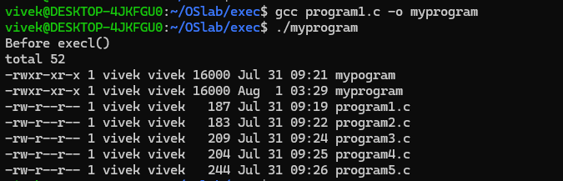

execlp() – Execute with List + PATH - Program2:
Output:
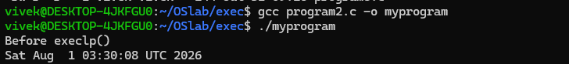

execv() – Execute with Vector - Program3:
Output:
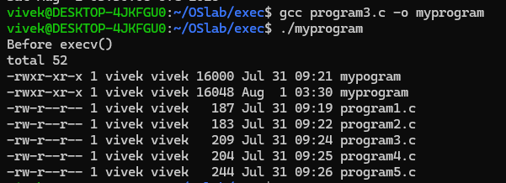

execvp() – Execute with Vector + PATH - Program4:
Output:
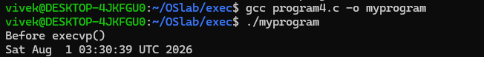
execve() – Execute with Vector + Environment - Program 5:
Output:
